**MAB Staff VPN - How to Change Password / Forgot Password**

Go to SSO login page.

<https://sso.malaysiaairlines.com/> or https://desktop.pingone.com/mab

Insert MH Domain ID and Password

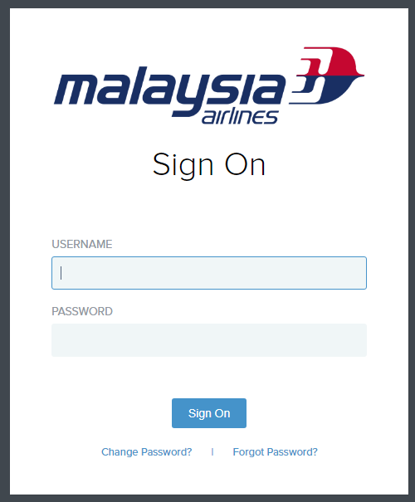

Click My Security Center

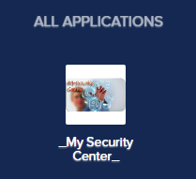

Click Self Password Change - VPN and SAP

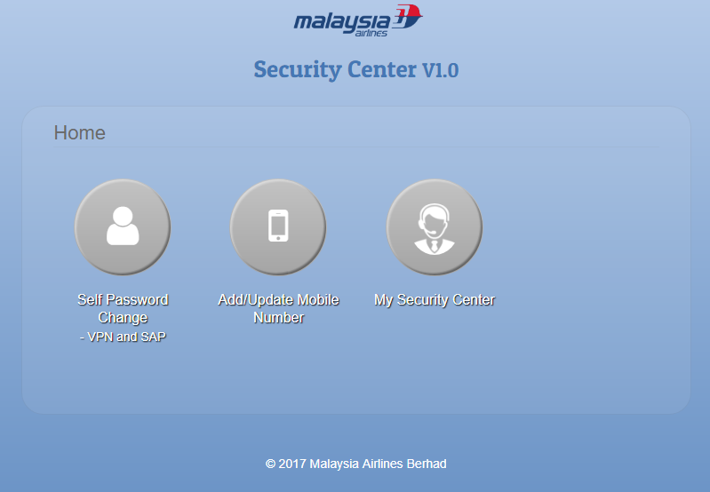

Click on VPN button

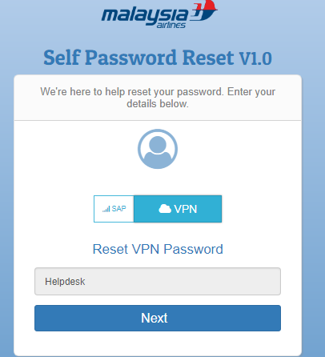

**Your staff ID automatically will appear in the box. Just Click Next button**

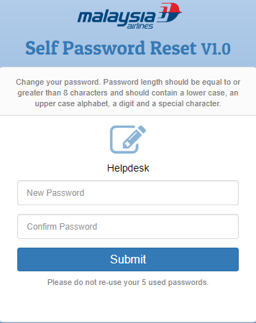

Key-in your new password and submit.